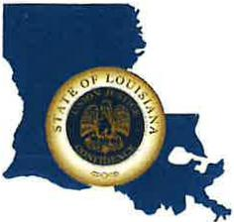 | CAPITAL AREA GROUNDWATER CONSERVATION DISTRICT
GARY I. BEARD
EXECUTIVE DIRECTOR

MEETING NOTICE
Capital Area Groundwater Conservation District
Administrative Committee Meeting

WHEN: Thursday, June 8, 2023

TIME: 1:30 p.m.

WHERE: Capital Area Groundwater office
3074 Westfork Dr., Suite A
Baton Rouge, Louisiana. 70816

Contact Person: Lisa Manda, (225)293-7370

